(Approx. 1450 words)

Financial Software
By Dick Maybach, Member, Brookdale Computer Users Group, NJ
August issue, BCUG Bytes
www.bcug.com
n2nd (at) att.net

I, like many others, have used Quicken for years to manage our family finances. In 2015 Intuit sold it, and the new owner has recently decided to make it a subscription product, requiring users to make periodic payments. So far, Intuit continues to support versions prior to 2015, and you can use these with no added fees. However, if you purchase a new PC, you may not be able to install your existing Quicken on it. What are the alternatives?

I use the software only for our checking account and enter all the data into it manually; moreover, I don’t use it to transfer funds electronically. Although TurboTax can import data directly from Quicken, I don’t use this feature either. As a result, I have considerable flexibility in choosing a program. I evaluated accounting programs by importing our data from Quicken and using them in parallel with Quicken for several months. During this time, I entered the new checks and deposits, reconciled the account, and prepared reports. This let me check that the programs would do what I need and compare the efforts required. If you’ve used Quicken for many years, you will find any new program quite awkward at first. A fair trial requires considerable study of the documentation and should extend over several weeks.

There are dozens of financial programs available, and I selected two of these for evaluation, GnuCash (http://www.gnucash.org/) and HomeBank (http://homebank.free.fr/en/). Both are free and run on Windows, OS X, and Linux. I’ll illustrate their characters by using a simple example checkbook record imported from Quicken, shown in Screen 1.

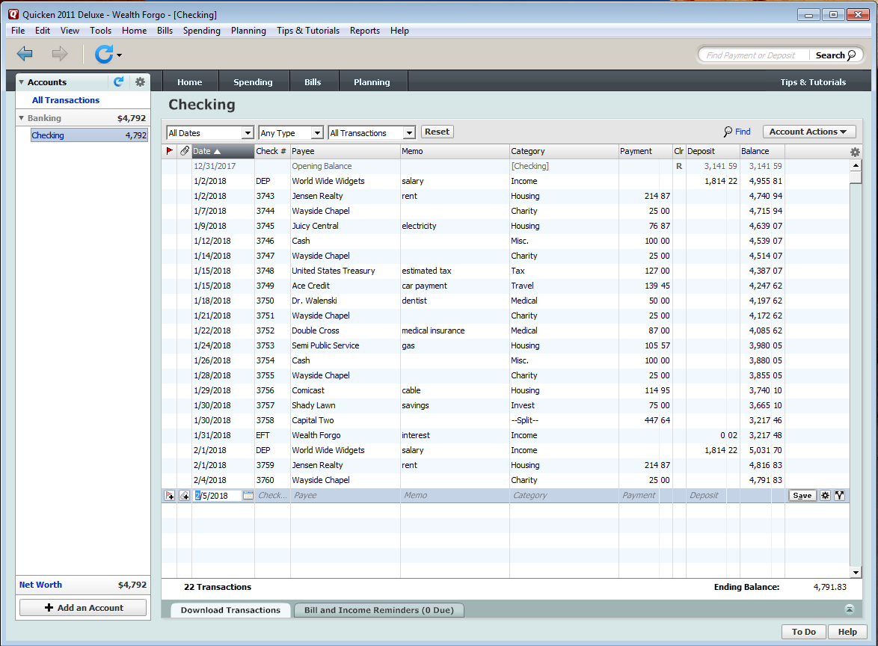
Screen 1. Quicken View of the Account.

Quicken uses single-entry book-keeping, where there is only one account, and the deposits and withdrawals are assigned to categories (income, housing, charity, etc.) Note the first entry (Opening balance). A Quicken feature allows you to close out an account, for example at year’s end. Items prior to the closeout date are placed in a separate file and deleted from the current one.

HomeBank, like Quicken, uses single-entry book-keeping, and while this is easy for most home users to understand, it isn’t really suited to business use. Importing the Quicken data resulted in two accounts, one representing the opening balance in Quicken and the other the subsequent transactions. The opening balance account can’t be deleted, but it can be hidden. Doing this and renaming the other resulted in Screen 2.

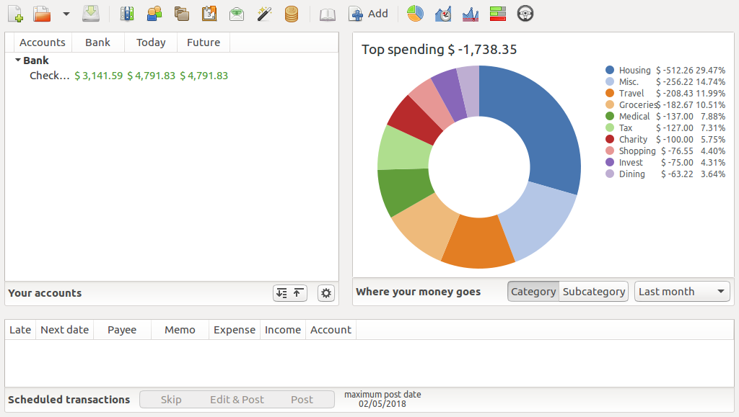
Screen 2. HomeBank Summary Screen.

From here you see a graphical summary of your spending, configure the program, select reports, and set up budgets. Double-click on an account to see the transactions, Screen 3.

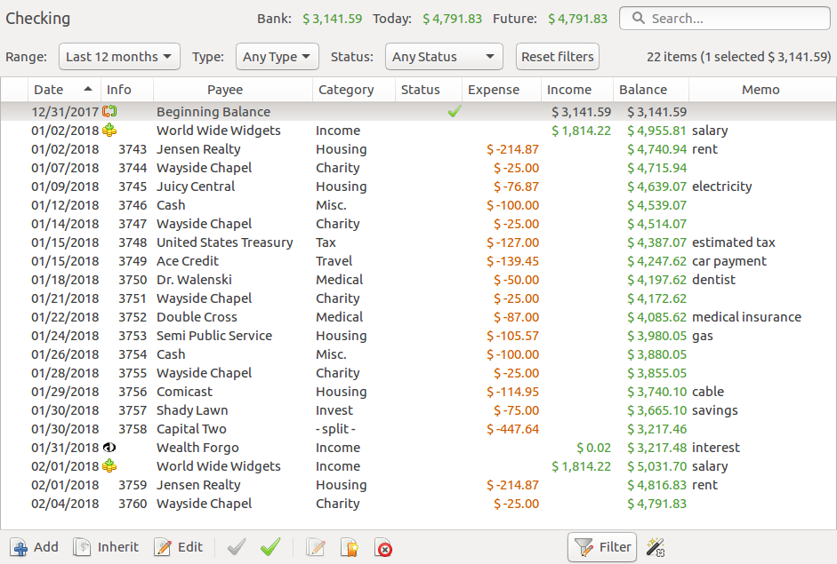
Screen 3. HomeBank Account View.

Unlike Quicken, there is no separate screen to reconcile an account. Instead, you select a transaction that appears on your bank statement and click the green check icon in the lower menu bar, after which a green check mark will appear in the Status column. The Bank item in the header shows the account balance of all the cleared items. When it equals the closing balance on your bank statement, the account has been reconciled. Click the Add icon in the lower menu bar to add a transaction or double-click on one to edit it; the result is Screen 4.

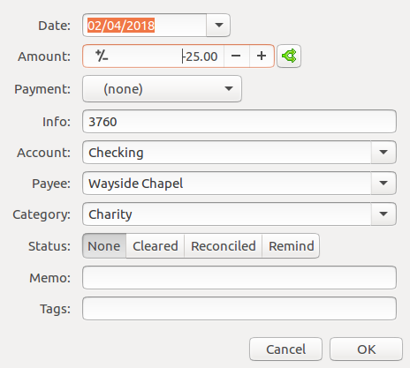
Screen 4. HomeBank Transaction Edit Window.

Although HomeBank is simple and easy to use, I found it somewhat more cumbersome than Quicken, in that entering transactions required a few more keystrokes. There also are no provisions for on-line banking. The F1 key opens the on-line manual, which of course requires Internet access. HomeBank can import QIF, QFX, and CSV files, and can export QIF ones. Thus, if you find after using it for a while that it isn’t suitable, you can move your data to another program.

If HomeBank doesn’t meet your needs, you might consider the more complex GnuCash. It uses double-entry accounting, which makes it suitable for business use and for organizations who are subject to audit, and it includes features for asset management and on-line banking. Its home screen, shown in Screen 5, hints at its double-entry approach.

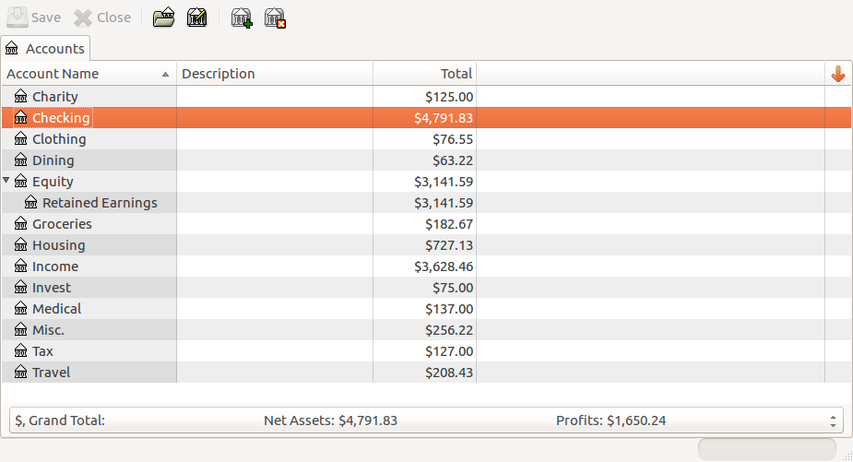
Screen 5. GnuCash Home.

Unlike in Quicken, there are no categories; instead there are multiple accounts. Checking accounts are essentially the same as in single-entry systems; the others take similar roles to categories. When you write a check to a charity, you deduct from the checking account and add to charity account. There is thus a plus for every minus, hence the term, “balancing the books.” Note the Retained Earnings account, which is the account’s opening balance. (GnuCash handled this more gracefully than did HomeBank.) Double-clicking on the checking account shows its transactions, Screen 6.

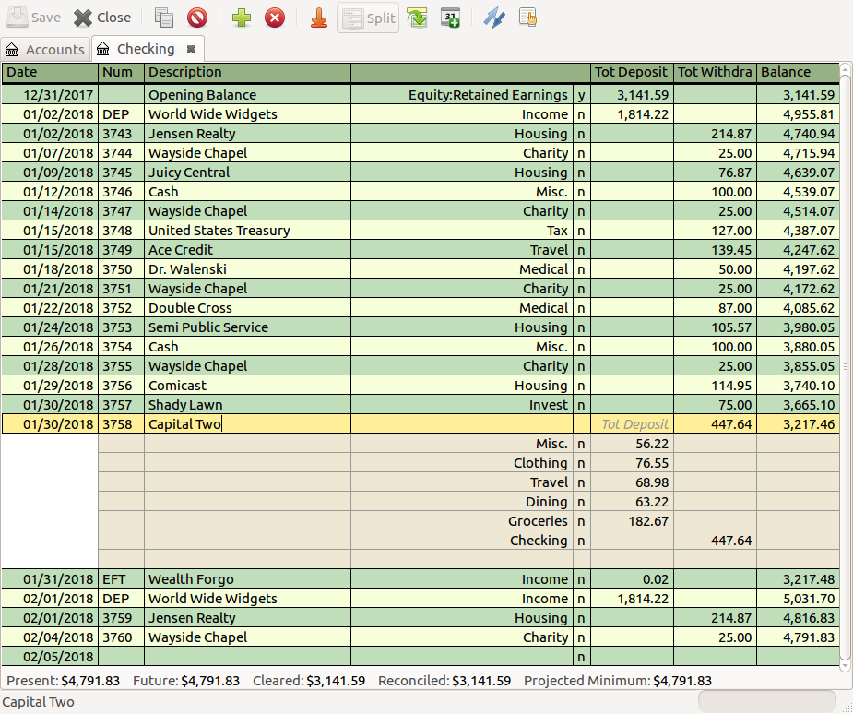
Screen 6. GnuCash Checking Account Transactions.

We see essentially the same information as with HomeBank and Quicken. A nice feature is that selecting a split transaction (Capital Two here) displays its component transactions. Like Quicken, GnuCash has a reconciliation feature, which leads you through the process, shown in Screen 7.

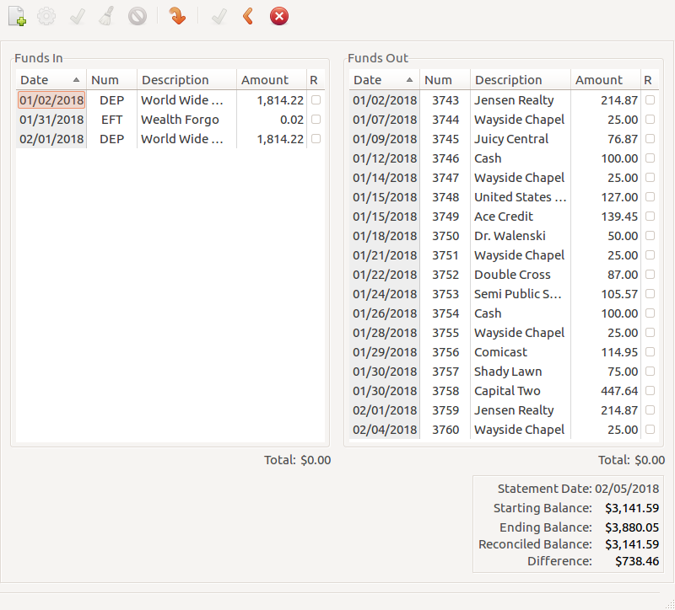
Screen 7. GnuCash Reconcile Window.

If you’ve had no exposure to accounting, it will take some time to adapt to the double-entry system, although it’s briefly explained in the tutorial on their website. For example, unlike in Quicken, when using GnuCash, once you’ve reconciled a transaction you shouldn’t change it. If you find an error in a reconciled transaction, you enter a separate transaction to make the correction. Once I became acquainted with GnuCash, I found it quite easy to use, although entering transactions is slightly more cumbersome than with Quicken.

A peculiarity worth mentioning is that while GnuCash can import data files in several formats, including QIF, QFX, and CSV, it can export only in CSV. Many programs, including Quicken can import only QIF files. Software is available to convert CSV files to QIF, but it involves additional work (and additional chances for mischief), especially since Quicken is fussy about the flavor of QIF. Another caution is that all the discussion I’ve seen on importing is for Intuit’s versions of Quicken; I don’t know if there are problems with the new one.

A bonus GnuCash feature is that it has a companion Android app that can export data to the PC program. You can use Android GnuCash to track credit and debit card transactions, and if you have the device with you, you know the card balances as you make the transactions. When you get a statement, you export the data to the PC and reconcile the account. Now your records show the card transactions as well as the checks. It will take some time and effort to learn to make this work, as reconciliation involves both the bank and card accounts and hence is a little tricky.

GnuCash’s advantages made mastering its double-entry basis worth the effort for me. Much of my spending is via credit and debit card transactions, which are now automatically included in my records. I also find the GnuCash reports to be more helpful than Quicken’s when preparing my tax return. It does take slightly longer to enter each check but being able to import card transactions from Android balances this.

Although I test-drove these two programs by importing data from Quicken, this may not be the best strategy to make the change. The import process isn’t perfect and may result in artifacts that are at least esthetically unpleasing. For example, although the process went smoothly for GnuCash, after importing over ten years of Quicken data into HomeBank I found that the Income category had been classified as an expense. You may prefer just to pick a date (probably January 1) and to begin entering data into the new program. To prepare for this, you would enter data in both during November and December, so that you would be comfortable using the new program by the change-over date.

One minor caution, TurboTax can import transaction data only in TFX files, and although Quicken and GnuCash can export these, HomeBank cannot. However, using this feature greatly increases the amount of data you must enter for each income item and requires that Quicken or GnuCash be configured carefully. For most of us, entering the data from our W2 and 1099 forms is far easier.

To answer my initial questions, yes there are viable free alternatives to Quicken that you can use for your home, organization, and small business. They aren’t clones and adapting to them will require time and effort. Be prepared to spend several months using your present accounting program and its replacement candidate(s) in parallel before making the switch. You may decide that Quicken is worth its subscription price.

